**CRIME CATCHER**

**Computer Engineering - Senior Project Report**

**Advisor :** Zeynep Filiz Eren Doğu

**Group Members :** Aslı Yavuz-Çağatay Şenturca

**Date :** 14/06/2019

**Introduction**

Worldwide crime rates are increasing every year and endangering us. More events occur, especially for those unfamiliar with a region. For this reason, with the application we have developed, we aimed to make people face less crime.This app will alert you to new and never visited areas and save lives. How it works?

1-You input the city you want to go

2-You input the region you want to go

3-You input the month you will be there

4-You inout the day you will be there

5-You input the time range

After you scan the database, the application will bring you the most processed crime according to the information you have entered in that area.

**Methods**

To do this app we worked dataset containing records from the new crime incident report system which includes a reduced set of fields focused on capturing the type of incident as well as when and where it occurred in Boston. Firstly, we answered the question below;

1. How has crime changed over the years?

2. Which areas of the city have evolved over this time span?

3. In which area most crimes are committed?

We plot all of them created an interface to analysis better.

We code the app in R by using R studio and we design our user interfaces in Shiny app.

**SCREENSHOTS OF PROJECT**

1. In this section, you can analyze data better and filter the data within the specified time interval. In the lower part, we will make more detailed filtering.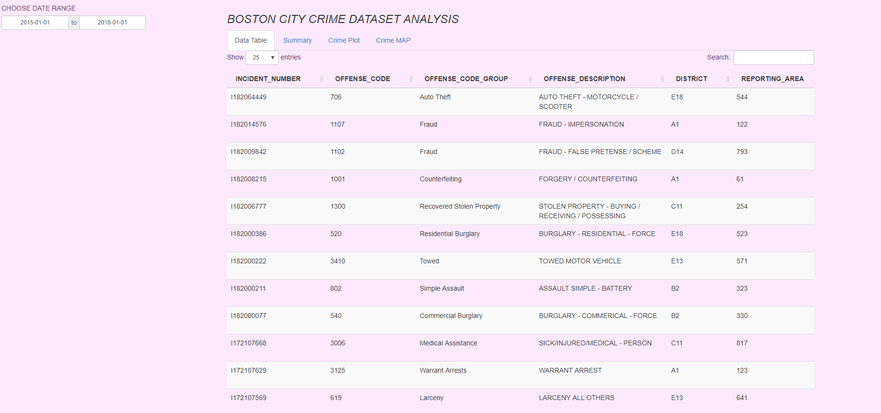

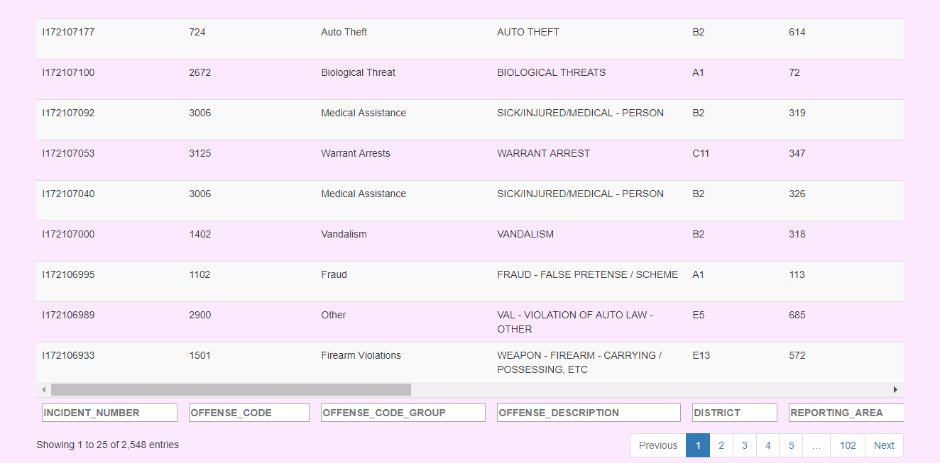

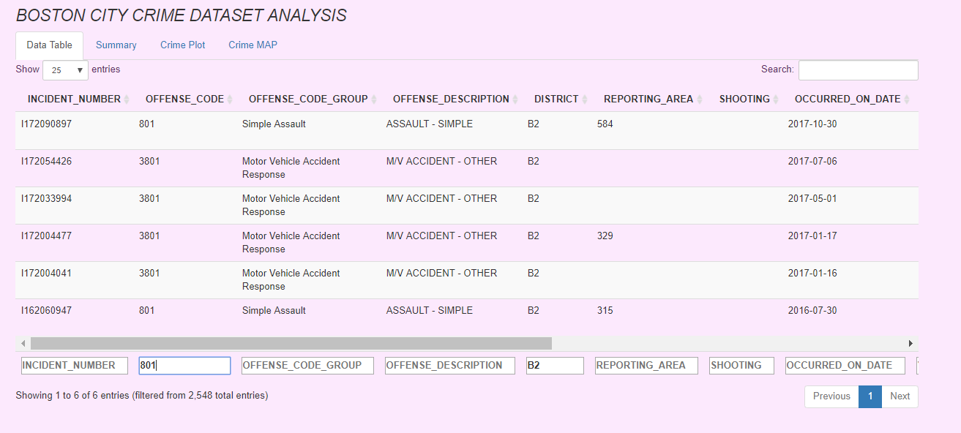

2.Summary of the data

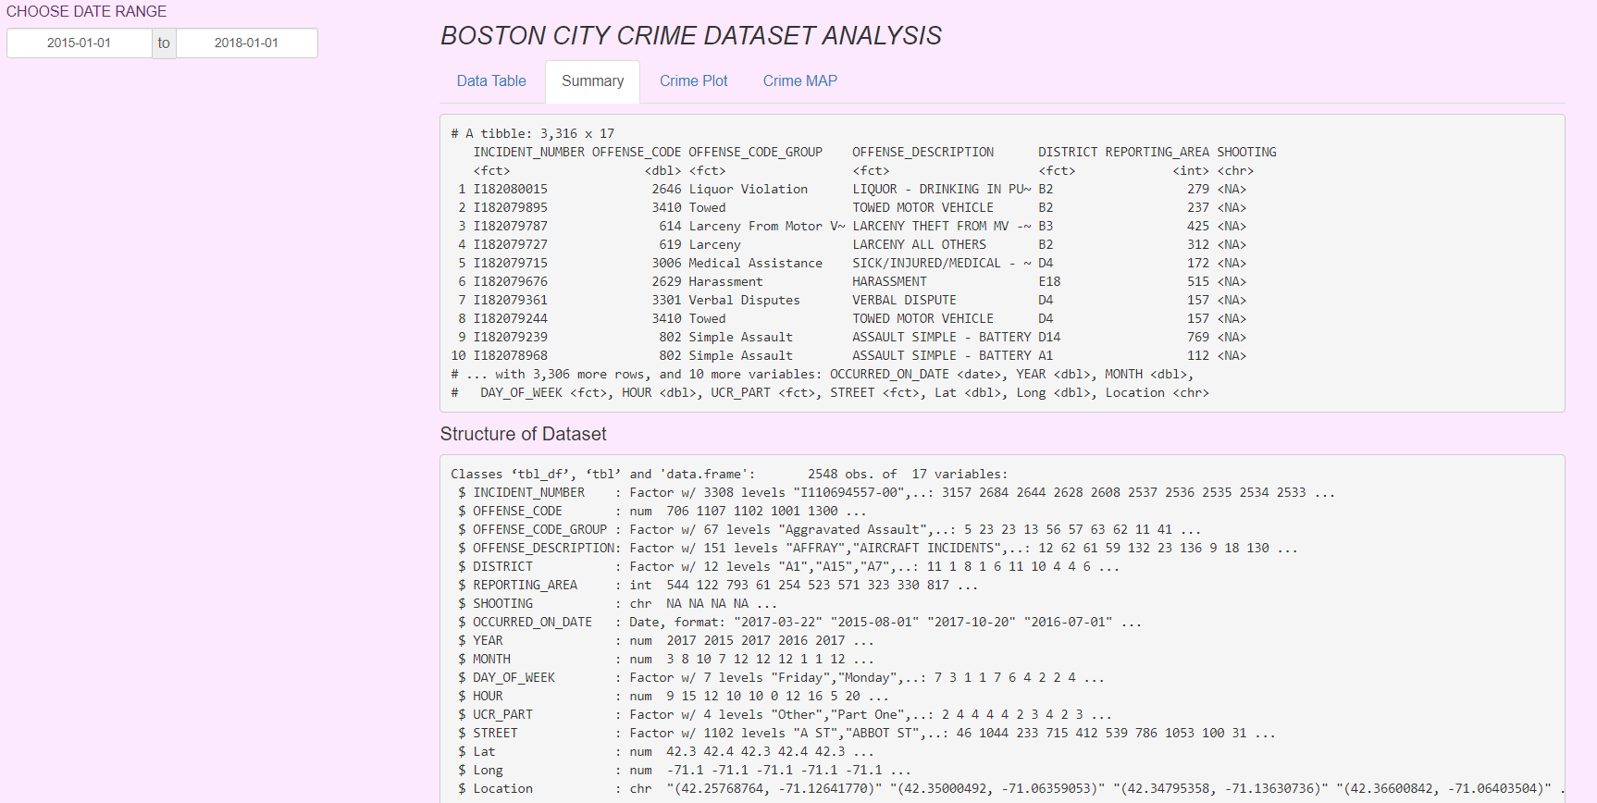

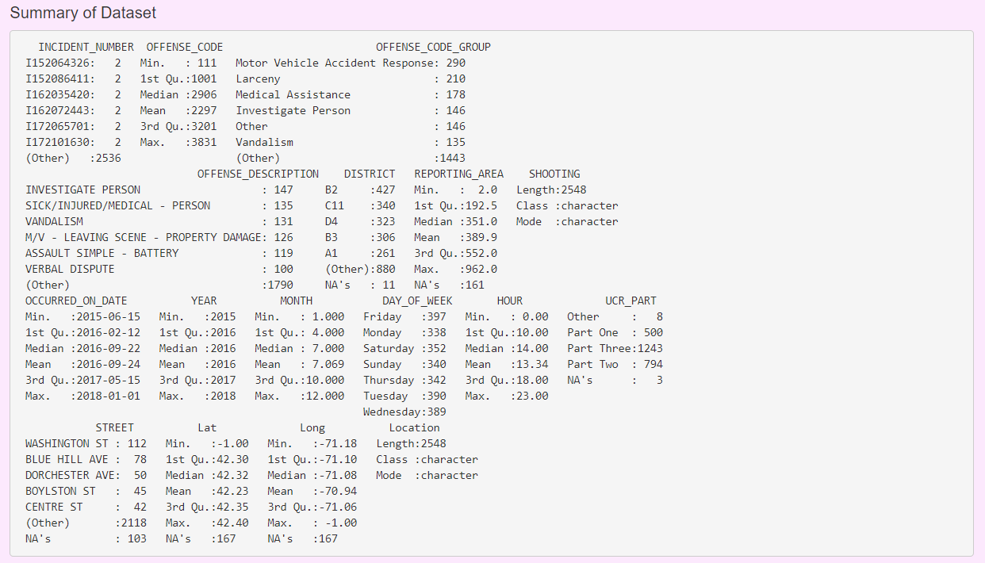

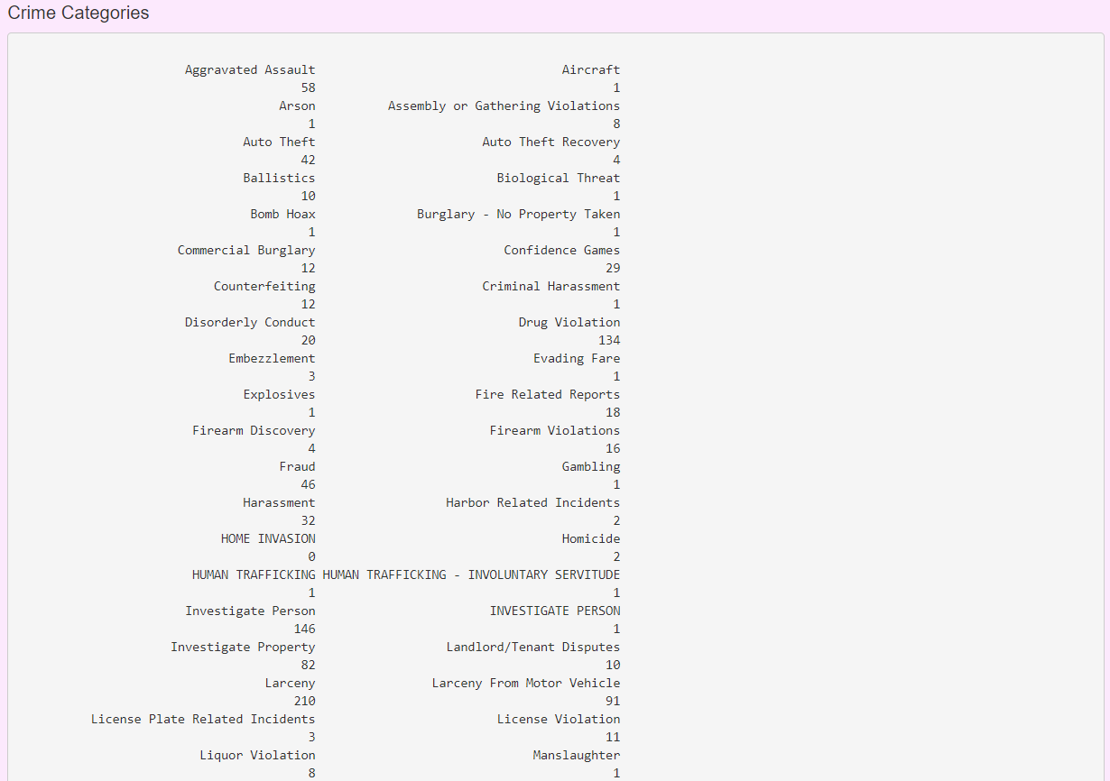

3. In this section, the answers to the above questions are graphically answered.

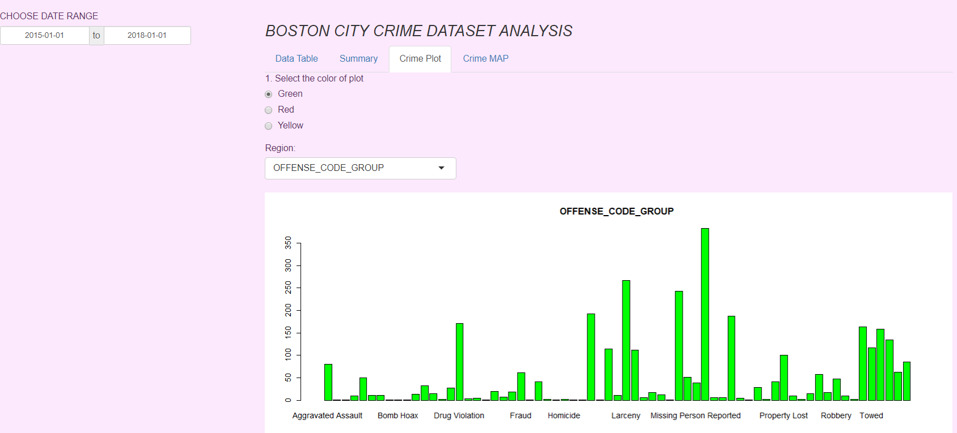

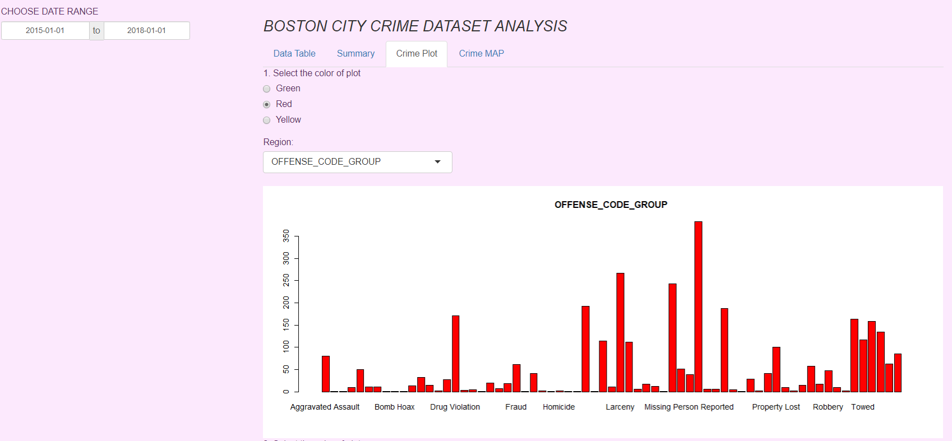

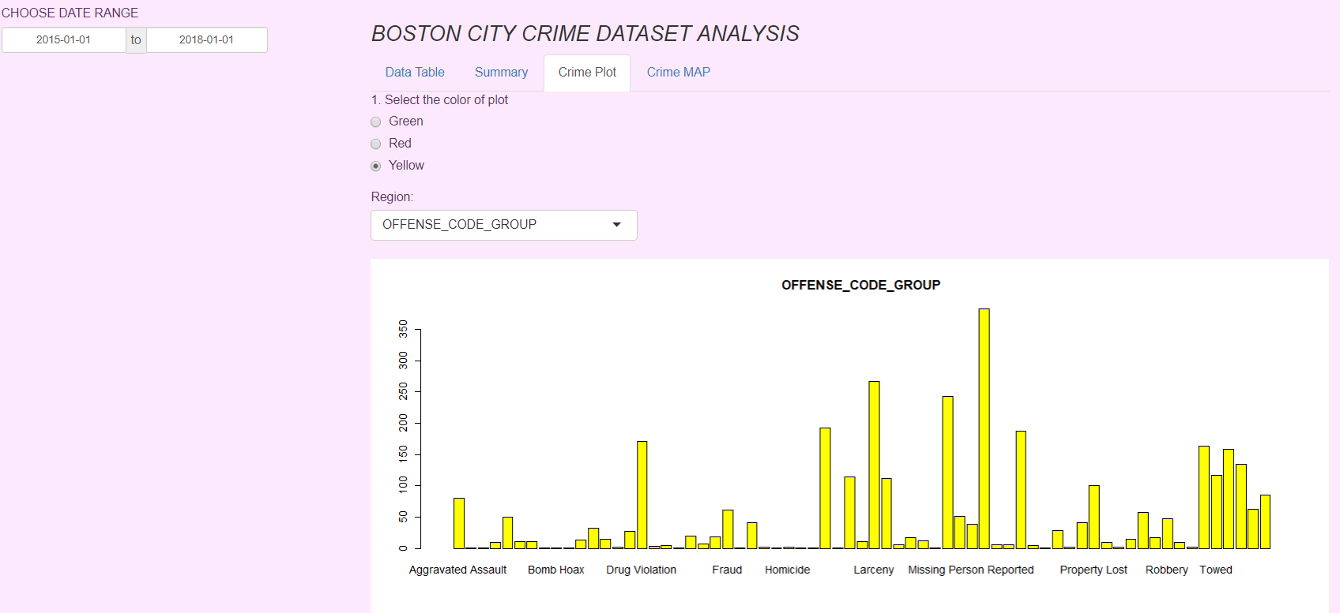

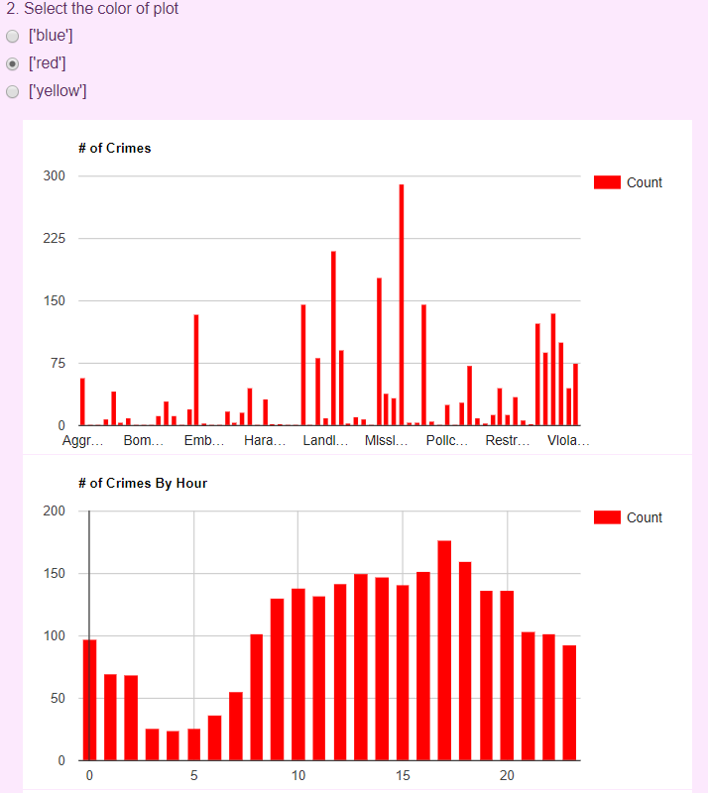

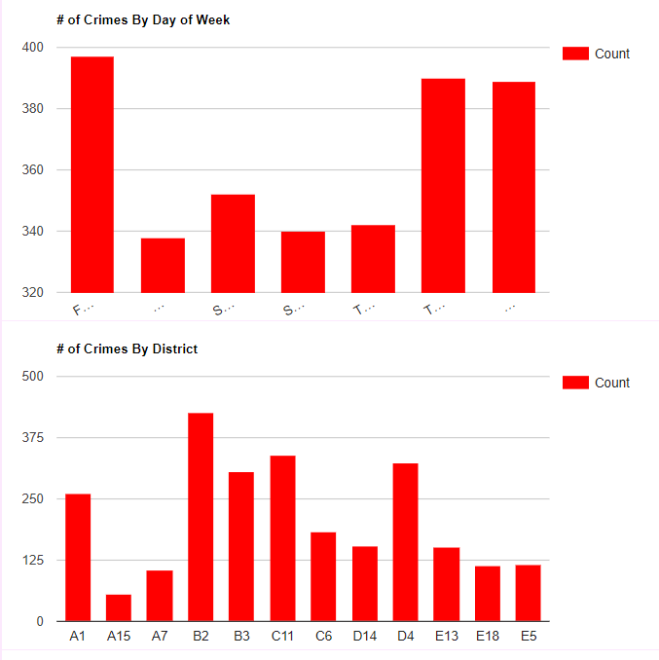

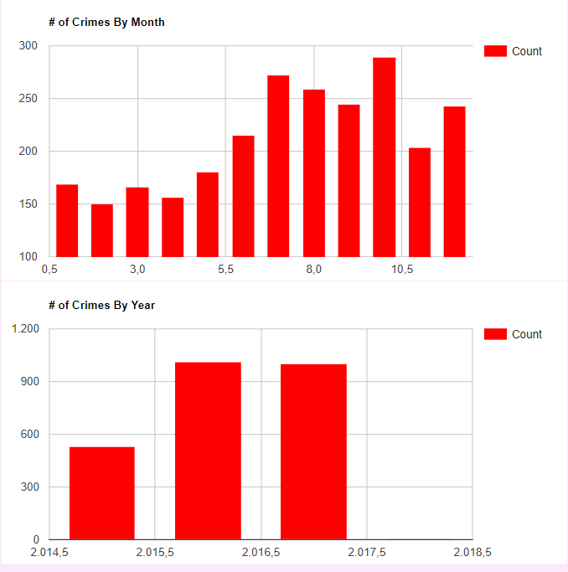

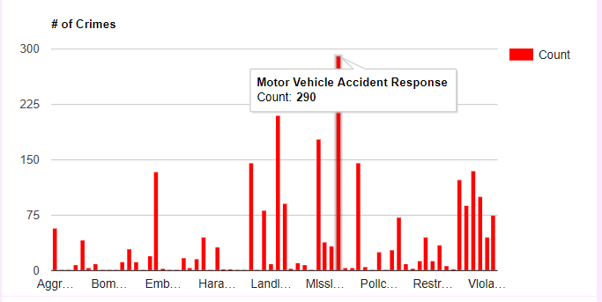

4. In this section crimes are positioned on the map and has the interface of the application that alerts you with information received from users.

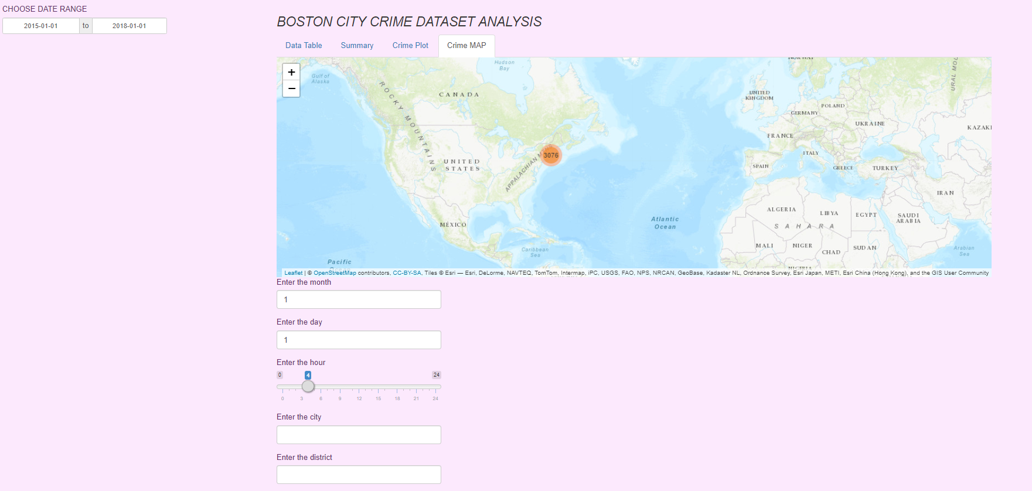

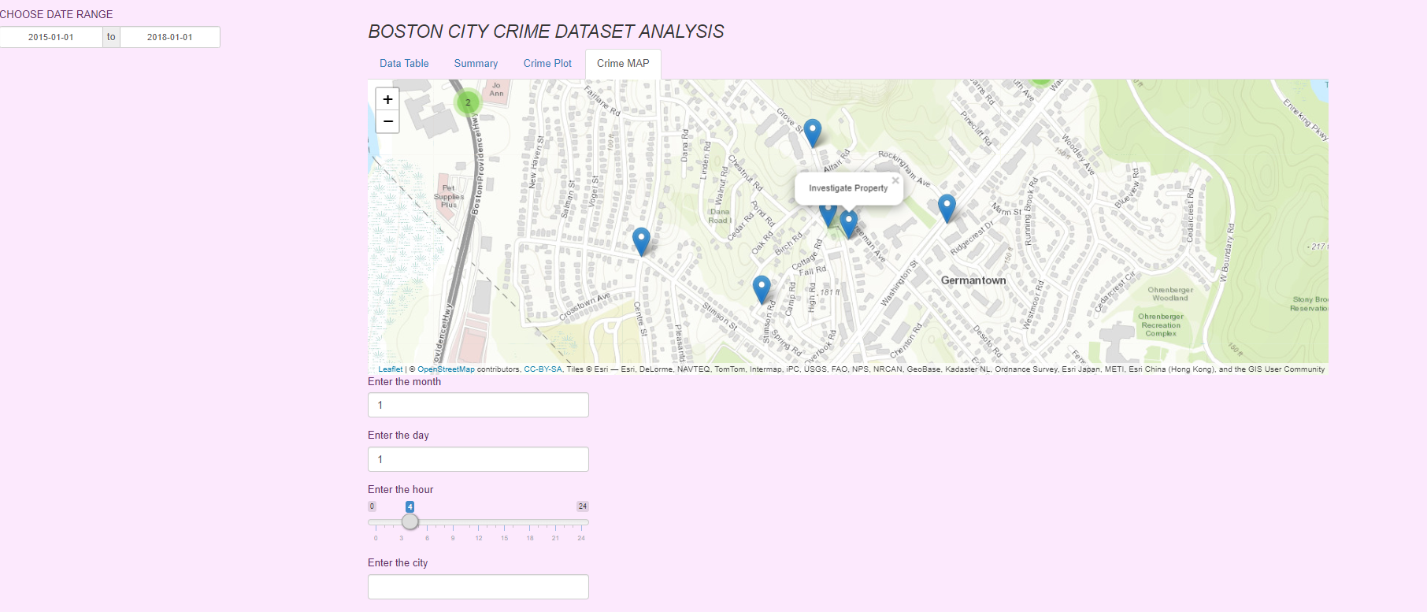

**Conclusion**

With this application we have provided the crime rates of the regions where the user wants to go. We received 5 different information from users to do this, and after scanning our database system, we gave results to users. With this application, we aimed to reduce the increasing crime rates and to ensure that people are not victims. Our project, which is open to development, has an infrastructure ready to be applied in every field.

**References**

**1.** <https://www.kaggle.com/AnalyzeBoston/crimes-in-boston>